Extended ACL Configuration

How to configure extended access control list

Inacio Andre

2024

// TOPOLOGY //

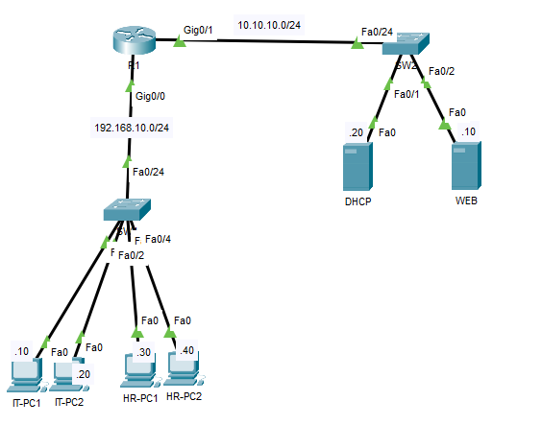

// BASIC CONFIGURATION //

\*\*R1

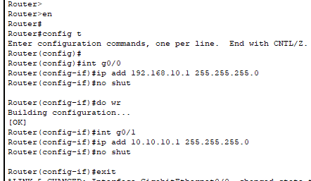

// ACL CONFIGURATION //

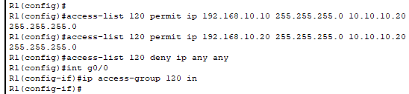

// TEST COMMUNICATION AFTER ACL CONFIGURATION //

IT-PC1 TO DHCP SERVER

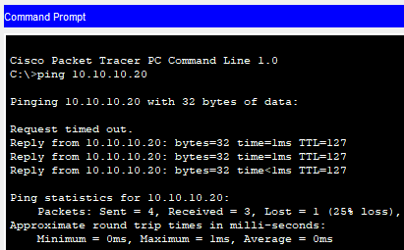

HR-PC1 TO DHCP SERVER

